**Coursework**

Applied Statistics and Data Visualization

(Principles of Data Science)

**MSc Data Science**

Comparing Major Economic Indicators of 10 of the

World’s most Advanced Countries

AND

Comparing the Rate of Economic Growth between Two

Continents of Africa and Europe

**Sakirat Adebukanla Osimade**

08/12/2022

**Table of Contents**

**Part One** 3

Comparing Major Economic Indicators of 10 of the World’s most developed Countries………… …….3

1. Introduction 3
   1. GDP Per Capita 3
   2. GNI Purchasing Power Parity 4
   3. Unemployment 4
   4. Terms of Trade………………………………………………………………………………….4
2. Background Research………………………………………………………………………………5
3. Exploration of Datasets… .9
4. Investigation of Data Workflows & Proposal for Design of Dashboard 11
   1. Use of DAX 11
   2. Use of Measures 12
   3. Use of Relationships……………………………………………………………………….……18
   4. Visualization 18
   5. Forecasting………………………………………………………………………………………
5. Discussion .26
6. Conclusions 27

**Part Two** 28

Comparing the Rate of Economic Growth between two Continents of Africa and Europe…………….28

1. Introduction 28
2. Background Research……………………………………………………………………………29
3. Exploration of Datasets 31
4. Analysis……………………………………………………………………….…………………34
   1. Descriptive Analysis 34
   2. Correlation Analysis 35
   3. Regression Analysis 36
   4. Time Series Analysis……………………………………………………………………….…39
   5. Comparative Analysis…………………………………………………………………………46
5. Discussion 48
6. Conclusions 48

**Part Three** 49

References and Appendices 49

# Part One:

# An Interactive Dashboard Design to Compare Major Economic Indicators of 10 of the World’s most Advanced Countries

# 

**1. Introduction**

As a Data Scientist at a Non-Government Organization involved in social and economic development Globally, and to demonstrate part of my role which is to use data in communicating issues to the wider public, I am designing an interactive dashboard which compares Major Economic Indicators of 10 of the World’s most Advanced Countries with a view to identify which countries perform the best with respect to major Economic indicators and identifying what the countries are doing differently.

The objectives for this design include the following.

* 1. **GDP Per Capita:**

To compare the GDP Per Capita of 10 of the World’s most advanced Countries.

Per Capita gross domestic product (GDP) is the economic output per person in each country. Based on the pace of economic growth, it gauges a country's prosperity. The estimated economic output per capita was calculated by dividing each nation's GDP by its population. (Reference: World bank Metadata Glossary)

* 1. **GNI Purchasing Power Parity:**

To compare the Gross National Income Purchasing Power Parity of 10 of the World’s most advanced Countries.

A country's standard of life, average level of education per person, and degree of inflation influencing its currency are all measured using GNI

PPP, or gross national income divided by buying power parity. (Reference: World bank Metadata Glossary)

* 1. **Unemployment:**

To compare the Unemployment Rate of 10 of the World’s most advanced Countries.

* 1. The percentage of a labor force that does not have paid employment despite being available for and looking for work is referred to as the unemployment rate. (Reference: World bank Metadata Glossary
  2. **Terms of Trade:**

To compare the Terms of Trade of 10 of the World’s most advanced Countries.

The percentage difference between the price index for exports and the price index for imports is known as the terms of trade. If a country's export prices go up at a quicker rate than its import prices, then the country's terms of trade are favorable. (Reference: World bank Metadata Glossary)

This was calculated by dividing the Export Index by the import index and the result was converted into a percentage format.

The Countries selected for this comparative analysis design include.

1. Country of Norway
2. Country of Switzerland
3. Country of Ireland
4. Country of Hong Kong
5. Country of Iceland
6. Country of Germany
7. Country of Sweden
8. Country of Canada
9. Country of America
10. Country of Belgium

# 

# 2. Background Research

For this research work, I would be making use of the Dashboard and Data Visualization tool of PowerBI using the principles of single screen dashboards.

Information overload is a well-known issue associated with the ongoing growth in data that must be handled. Dashboards, one of the most effective tools in business intelligence, can be used to manage this overload by combining several concepts, scorecards, for instance, can assist stakeholders and employees in performance enhancement and making the best decisions.

*“A dashboard is a visual depiction of the most critical data required to complete one or more goals, gathered and arranged on a single screen for simple monitoring. Typically, dashboards are used in conjunction with enterprise resource planning (ERP) systems.****”*** (Reference: Stephen Few; source: PODS Course Materials 2022)

*It is evident that there is a knowledge gap about the effectiveness and scientific applications of dashboards, as opposed to just using them as a piece of art to draw in new clients* (Reference: Stephen Few)

*“Key business metrics are tracked and monitored centrally using an interactive dashboard, a data management tool. With the help of various interactive features, users can explore the data on a deeper level and make well-informed, data-driven business decisions****”*** (Reference: DataPine.com)

*“Data visualization is the process of graphically presenting information and data. Data visualization tools offer a simple way to find and understand trends, outliers, and patterns in data by utilizing visual elements like charts, graphs, and maps. Utilizing the tools will enable you to do this****.”*** *Graphically representing data is effective because of how our brain processes visual information.* (Reference: <https://www.tableau.com/en-gb/learn/articles/data-visualization>; Source: PODS Course Materials 2022)

Power BI, which is built by Microsoft, is a piece of visual analytics software that can be interacted with and focuses mostly on business analysis. Power BI is a collection of software services, applications, and connections that, when combined, convert heterogeneous data sources into unified, interactive graphics and insights. When entering data, one option is to read it straight from a databases, web, or organized file type such as a spreadsheet, CSV, XML and JSON” (Reference: Wikipedia, the Free Encyclopedia)

Dashboards in the last 10 years have become a standard Business Tool with several companies coming up with solutions to meet the increased demand of end users. The most important factors to pay attention to, in building the most effective dashboards is being designed focused, thoughtful and user-friendly, seeking a union of Utility, usability and finesse.

For an effective dashboard, we must identify the target audience and ensuring to design for the audience understanding, assimilate the type of dashboard to be created and the value to the organization its being created for. In addition to this we must lay out our dashboard design in line with best practices for creating charts and visualizations.

The most recent developments in interactive dashboard design include the use of tools designed for analytics, Business Intelligence and dashboards. The top 4 of such tools include:

* 1. Microsoft Power BI
  2. Tableau
  3. Good Data, and
  4. Databox

For this research work, I would be utilizing the tool of Microsoft Power BI.

# Single Screen Dashboards

These are dashboards that present a visual representation of the most crucial data needed to accomplish goals that is condensed and displayed on a single screen so that the data can be viewed quickly.

The general Visualization Guidelines include:

* Data-Ink Ratio
* 3-D Effects
* Use of Color
* Accessibility
* Ordering
* Annotations
* Scale and axes

The principles of a single screen dashboard include the following.

* To communicate information quickly
* To Choose the right Data Visualization tool and technique
* To show trends and changes in data over time
* To display information clearly in a visual hierarchy
* To make effective use of Color and be considerate to Color blindness
* To reduce complexity while providing Clarity
* To provide quick “one click away” access to relevant information
* To use positioning and sizing to make priorities clear.

The composition of an effective single screen dashboard must fulfil the requirement of data Visualization using Visual Encoding. We assign visual attributed to visual elements. These visual attributes include.

1. Color
2. Shape
3. Position
4. Size
5. Contrast

# 3. Exploration of Data Set

The Dataset used for this Dashboard Design was accessed from the World Bank data repository at [https://databank.worldbank.org/source/world-](https://databank.worldbank.org/source/world-development-indicators) [development-indicators](https://databank.worldbank.org/source/world-development-indicators)

For this research work I would be using several indicators from the World’s bank collection to compare 10 advanced countries in the World over a 10-year period. The Countries are Belgium, Canada, Germany, Hong Kong, Iceland, Ireland, Norway, Sweden, Switzerland and USA. The period covered is from 2011 – 2020.

To Compute the GDP Per Capita Indicator, I would be using the GDP datasets and the Population Datasets. The Population Datasets of Male and Female will be added using a Dax formula to get the total Population. This will then be divided by the GDP to get the GDP Per Capita for each Country.

To compute the Terms of Trade indicator, I would be using the Import and Export indexes. Export index will be divided by the import index and the resulting value multiplied by 100.

Other datasets to be used for this research include the GDP PPP (Gross Domestic Product Purchasing Power Parity), for every country under consideration, there are databases on unemployment as well as gross national product (GNI PPP). The Dataset selected will be explored using R Studio to ensure its usable for the research work.

This will then be loaded to Power BI. New Columns will be added using DAX Function for the Calculations. Large decimal numbers will be changed to Whole Numbers to effectiveness. Columns like Country Code and Time Code will be hidden as its not required.

New Table will be created for Calendar to create relationship between the tables of the different World Development Indicators.

Slicer function in Power BI will be used to ease representations on a Power BI canvas that make it simple for users to readily refine the data.

The Hierarchy Function in Power BI will also be used, it’s a collection of fields organized hierarchically, with one level serving as the parent of another level and the parent level's values drillable all the way down to the lower level.

# 4. Investigation of Data Workflows & Proposal for Design of Dashboard

# DAX (Data Analysis Expression) and Measures

A series of DAX was written and used for creating tables and measures to investigates different economic indicators for the selected ten (10) countries.

* **Calendar Table**

The calendar DAX function is used for creating a date table with a continuous series of dates. A given start date and a defined end date are both included in the range of dates. It provides a single-column table as a result which can be used as date key (primary key).

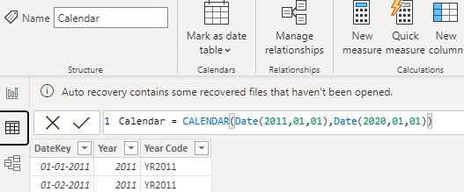

Fig. 4.1: Calendar Table

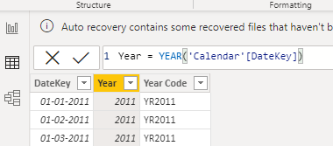

Fig. 4.2: Year column

From the year column, a year code was also created for each row using the Concatenate DAX function which combines two or more text.

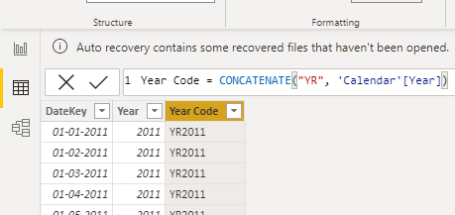

Fig. 4.3: Year Code column

The calendar table will be used for creating relationships and as a date filter for all tables in the data model.

* **Measures**

A measure is a mathematical calculation used to calculate values for each row in a table using the DAX language.

Different measures were created to be used for visualization

* FemalePopulation Measure is the sum aggregated values of the Female Population column.

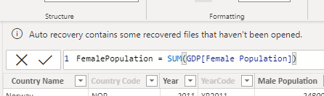

Fig. 4.4: Total Female Population

* MalePopulation measure is the sum aggregated values of the Male Population columns.

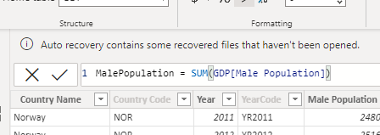

Fig. 4.5: Total Male Population

* Total GDP measure is the sum aggregated values of all ten countries GDP based on the GDP current column.

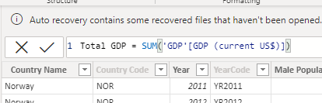

Fig. 4.6: Total GDP

* Total Population measure was created using SUMX DAX function which performs a row-by-row calculations and iterates through every row of GDP table to compute the sum of female and male population giving us the total population of the selected countries.

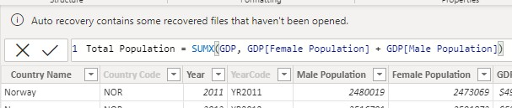

Fig. 4.7: Total Population

* GDP per Capita: A nation’s GDP per capita is frequently regarded as a barometer of its standard of living. It is calculated by dividing the total GDP by the total population

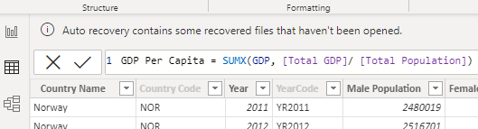

Fig. 4.8: GDP per Capita

* Total Export is the sum of merchandise exports and Commercial service exports of selected countries.

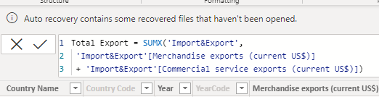

Fig. 4.9: Total Export

* Total Import is the total of imports of goods and Commercial service imports from selected countries

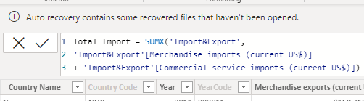

Fig. 4.10: Total Import

* Export to Import Ratio indicates if there’s a positive or negative trade, is calculated by dividing the value of imports by the value of exports of goods and services.

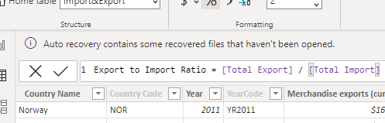

The expression “Total Export” and “Total Import” are measures created above.

Fig. 4.11: Export to Import Ratio

* Net Exports: the net difference between total export and total import.

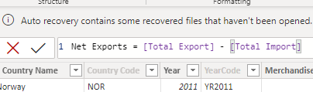

Fig. 4.12: Net Export

* Terms of Trade: defined as the proportion of total exports to total imports.

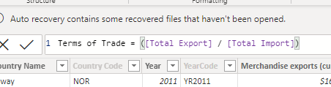

Fig. 4.13: Terms of Trade

* Trade to GDP Ratio: this is a measure of how significant international trade is to a country's economy as a unit. It is calculated by dividing the sum of all imports and exports for a period by the gross domestic product for that period, presented as a percentage.

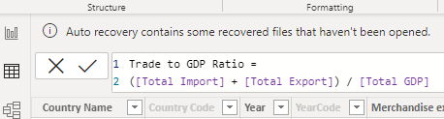

Fig.4.14: Trade to GDP ratio

* GDP PPP (Purchasing power parties): PPP attempts to balance the buying power of various currencies and removes regional pricing disparities. GDP PPP is the sum aggregate measure of the entire PPP column which can be filtered by individual country when selected in a chart.

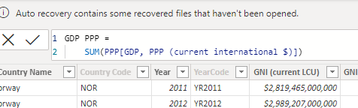

Fig. 4.15: GDP PPP

* Top 4 highest Unemployment rates: The percentage of a labor force that does not have paid employment despite being available for and looking for work is referred to as the unemployment rate. The unemployment rate is the portion of the labor force that is unemployed but actively seeking employment and willing to work. The unemployment rate is the portion of the labor force that is unemployed but actively seeking employment and willing to work. To get the top 4 countries with the highest unemployment rate we concatenated different DAX functions (SUMMARIZE and TOPN) to generate a table.
* SUMMARIZE function summarize a given data table rows into one table with a provided criteria column.

The TOPN function selects the top “N” from a given table, in our case the top 4 countries with the highest unemployment rate.

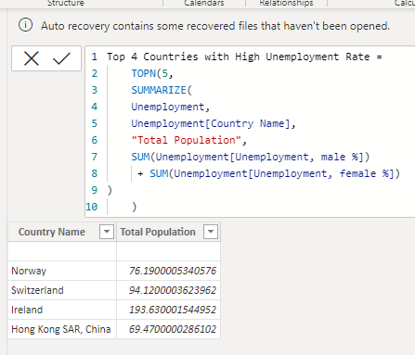

Fig. 4.16: Top 4 nations with the highest rates of unemployment

The following countries that have the highest unemployment rate in Norway, Switzerland, Ireland, and Hong Kong SAR.

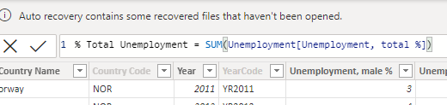

Fig. 4.17: % Total unemployment rate

* Female % unemployment: a total combined female unemployment rate of ten selected countries which can be filtered by country using a chart or slicer.

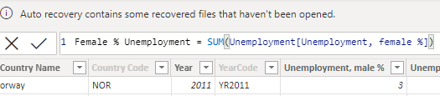

Fig. 4.18: % Female Unemployment rate

* Male % unemployment: a total combined male unemployment rate of ten selected countries which can be filtered by country using a chart or slicer.

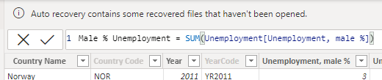

Fig. 4.19: % male Unemployment rate

* **Tables Relationships**: Table relationships are meaningful associations between tables that contain related information.

To establish a relationship between the tables two additional tables were created, one using DAX and the other by querying other tables.

Using country name columns from different tables to create a relationship will result in a many-to-many relationship with some links being active and others inactive which will lead to misinformation on how filters are applied to the tables in the dataset.

To fix such problems, an additional table was quarried and transformed to hold

only the unique names of countries in our dataset.

* + From the power query we selected the GDP table country name column and added it as a new query.
  + We converted the query from a list to a table.
  + Duplicated country names were removed to have unique country names.
  + Same procedure was done on the country code column.
  + The two tables were merged to create Country Table with the country name and country code columns.



Fig. 4.28: Country table

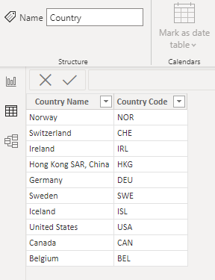

Fig. 4.29: Country table

From the above table, a one-to-many relationship is created with all tables in the model which will improve consistency through all country filters applied on visualization charts.

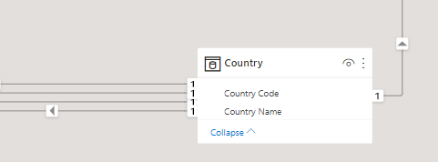

Fig. 4.30: Country Relationship

From the country table filters are applied only in one direction and all links are active.

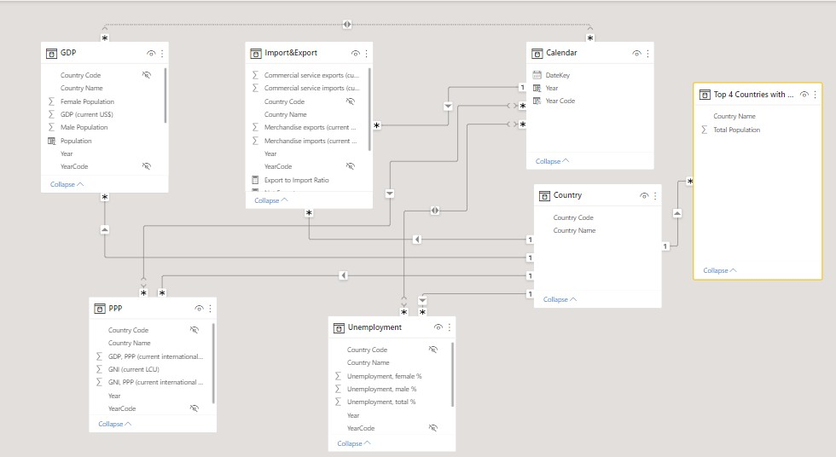

Fig. 4.31: Tables relationship

Each table has two links (relationship) established, one link to the Calendar table and the other link to the country table. Filters are applied in one direction.

* **Visualization**

Visualization is the process of representing and interpreting data in the form of visual terms such as pictures, graphs, or simulations. PowerBI has many visualization tools that can be used for representing data of different forms and showing different insights. We will create visuals using measures that we created from the dataset.

* **Card Visual**: displays a single number fact.

A card visual was implemented to display the following measures for the selected countries. The Card visuals can be filtered to display values of a specific country from a slicer or selection from another visual.

* + Total Export
  + Total GDP
  + Total Import
  + Total Population

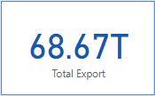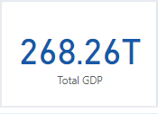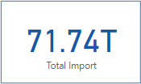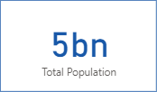

Fig. 4.20: Card visuals

* **Line Visual**: a graphical representation of historical data by connecting points of data using a continuous line. We used a Line chart to represent the total population of ten selected countries by year.

Our line chart indicates a continuous increase in the population every year. Using a forecast for a period of ten years shows an increase in the total population of the ten advanced countries.

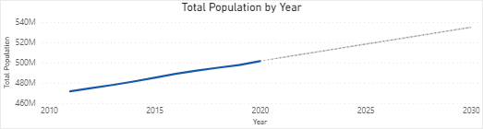

Fig. 4.21: Line visual

The bold blue line indicates the current data used, while the dashed blue line indicates the forecast for ten years.

* **Bar Chart**: A rectangular bar with height and length proportional to the values they represent. it is used to display categorical data.

We used a bar chart to display GDP per Capita by country.

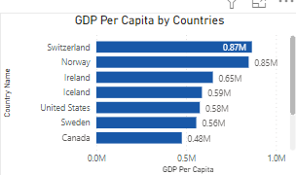

Fig. 4.22: Bar Chart

From the chart above Switzerland has the highest GDP Per Capita followed by Norway.

* **Map**: used to display categories and compare values across different geographic regions.

Our map visual is used to display trade to GDP ratio by country.

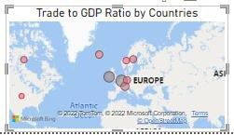

Fig.4.23: Map visual

The buddle size is based on the Trade to GDP ratio of the countries.

* **Column chart**: Displays categorical values using vertical bars with its height proportional to the values.

Our column chart represents the total population of individual countries with the USA having the highest population with approximately 3.2 billion followed by Germany with approximately 1 billion.

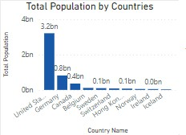

Fig. 4.24: Total population by country

* **Pie Chart**: A unique type of chart known as a pie chart employs pie slices to display the relative sizes of data.

We used a pie chart to represent the Export and Import ratio. Each slice represents a percentage from the total with United States of America topping Chart followed by Germany and then Hong Kong in third place.

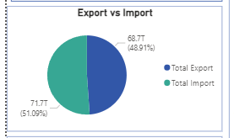

Fig. 4.25: Pie chart

* **Area Chart**: Area charts can be used to draw attention to the overall value across a trend and focus on the size of change over time. For this chart which is based on the principle of a line chart, the space between the axis and line is filled in. An area chart was used to display the top 5 GDP per Capita of countries by year.

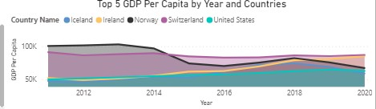

Fig. 4.26: Area chart

From the graph above we can state the following observations.

* + The GDP per capita in countries such as Ireland and the United States seems to be increasing steadily every year.
  + The GDP per capita of Norway seems to have dropped between the year 2014 to 2016 and 2018 to 2020.
  + The GDP per capita of Switzerland appears to be almost steady every year.
* **Slicers**: An independent chart called a slicer can be used to filter other visualizations on a power report. Slicers come in a variety of formats and can be configured to allow the selection of only one, several, or all the available values. (Category, range, date, etc.).

We added two slicers to our power bi report, the Year column from the Calendar table and the Country Name from the Country table.

* 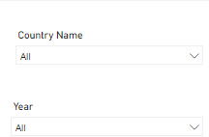

Fig. 4.27: Slicers

Both slicer’s Year and Country were converted to display as a dropdown list.

**Use of Forecasting Tool in Power BI:**

The forecasting tool used in Power Bi is in-built into Line Chart. Our line chart indicates a continuous increase in the population every year. Using a forecast for a period of ten years shows an increase in the total population of the ten advanced countries.

The bold blue line indicates the current data used, while the dashed blue line indicates the forecast for ten years.



**PowerBI Dashboard:**

A Power BI Dashboard is a multi-perspective look at a data model that includes visualizations for various discoveries and insights.

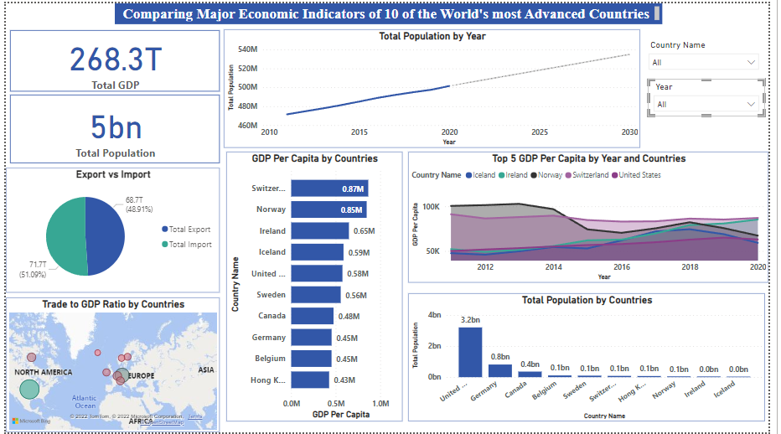

A power Bi Dashboard was created using different chart types

Fig. 4.32: PowerBI Dashboard

* Dashboard: All data is shown visually on a dashboard. Although it has a number of applications, its primary purpose is to deliver information that may be viewed and digested in a short amount of time.

The proposed dashboard was designed using different economic indicators to compare and understand the economic growth of ten world’s most advanced countries.

Before dashboard design, a one-page power report was first created from the cleaned dataset using the different chart types mentioned above.

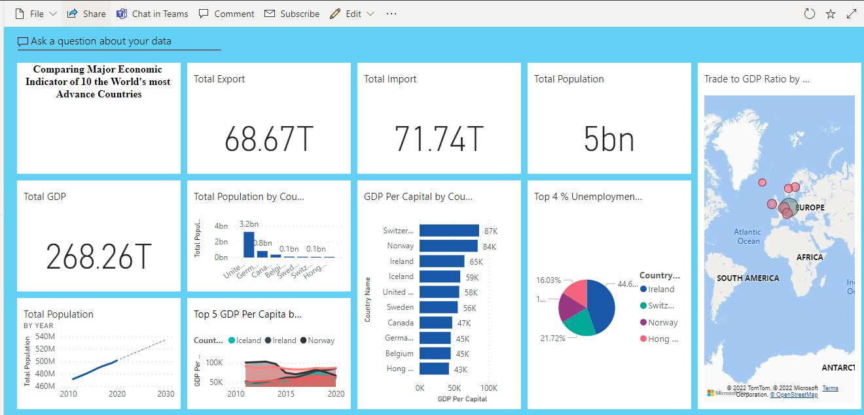

Fig. 4.33: Single Screen Dashboard

# 

# 5. Discussions

10 countries were selected in comparing the major indicators of the most advanced countries of the world.

A model was generated using the created and imported tables. From the model, different measures were created to analyze the selected economic indicators. These measures include; net export, terms of trade, export-to-import ratio and GDP per capita. We then use the measures in creating a PowerBI report from Power Desktop using different visualization which is the representation and interpretation of data in the form of visual terms. The visuals used are Card, Line charts, bar charts, column charts, map charts, pie charts, and area charts. Then filters were applied using slicers.

It is evident that Switzerland has the highest GDP per capita at an average of $87K over the 10year period examined, followed by Norway at $84k and Ireland at $65k. Putting these three at the top in the World.

It was observed from the dashboard that of the 10 countries examined, Ireland has the highest unemployment rate at 5.6% followed by Switzerland at 4.8% and Norway at 4.4% which puts these three countries as the top 3 of the most advanced countries that need to focus more on Job availability for their Citizens.

It is also evident that United States is the most populated Country among the 10 examined at 332M followed by Germany at 83M and Canada at 38M.

The report was published on Power Online Services, then different tiles were pinned to a new dashboard in My Workspace. We utilized the tool Microsoft PowerBI. It is free, has interactive reporting, and has user-friendly mobility over other workflows.

# 6. Conclusions

For investors, economic indicators are very important. They offer trustworthy information that enables investors to organize, plan, and carry out financial decisions. Analysts can assess economic activity and opportunities using indicators like GPD and CPI. The indicators offer clues and insight into economic trends when properly interpreted. An extensive overview of the state of the economy is given through economic indicators.

Analysts calculate economic indicators to analyze economic situations. They assess statistical data that represents past, present, or future patterns using financial information. The results of these calculations are largely used to assess the state of the economy. Calculating the GPD, for instance, reveals the nation’s overall productivity. Analysts can assess the strength or weakness of a nation's economic growth by comparing the GDP of various nations and years.

The dashboard's goal is to compile all information and data onto one screen in an easily readable and understandable way so that it can be monitored immediately.

The dashboard will also enable economic experts to view relevant information and compare similar performance indicators of different countries to help make better future decisions that will affect the lives of citizens of their countries.

The dashboard design gives a comprehensive overview of the status of the economy of a country and when compared with other countries.

# 

# Part Two:

# Comparing the Rate of Economic Growth between

# Two Continents of Africa and Europe

# 

# Introduction

Trading and investment are a key factor in Africa and one of the key investors and trading party is the European Union. The European union play a large role and take almost 32 percent of the investment that takes place in Africa. Most African countries cannot be where they are without the intervention of European union in terms of Economy, security and other external provision made as a support by the European countries. Africa is blessed with different nation who are blessed with essential mineral resources which are needed in the European countries due to this, African major export goes to the European countries through the European Union, and Africa remains and provides an essential small market for the EU. African nations have had relatively rapid economic growth for the past 15 years or more also the rise in migration brought on by crises and wars. Several recent African initiatives, including the African Continental Free Trade Area (AFCFTA), which was approved in 2019, and the African Union's Agenda 2063, demonstrate that continent's states are increasingly acting strategically and looking for opportunities for collaboration with all parties. It facilitates and increases the togetherness of former and present continental initiatives.

The primary goal of this research is aimed to compare the rates of economic growth on the two continents by fitting a time series Autoregressive integrated moving average (ARIMA) model that can forecast economic growth and a multiple linear regression model that reveals the significant influence of economic indicators on the economic growth for both continents at any time given the historical monetary values of all significant indicators.

# Background Research

The accuracy of GDP projections in a sample of 25 transition nations from 1994 to 2004 was examined by Krkoska and Teksoz (2007). The three Baltic States are among the several former Soviet Union states represented in the forecast sample. When only brief time series for a small number of variables were available, they were particularly interested in how forecasts were impacted by significant institutional changes. They concluded that the European Bank for Reconstruction and Development's (EBRD) predictions had been accurate. Six actual forecast errors did not follow an autocorrelation but rather a random walk. They discovered that as transition and data availability levels rise, forecast accuracy rises as well. The article also offers a thorough overview of earlier studies on forecasting as well as a review of the challenges involved in projecting macroeconomic variables for emerging nations. The models with short time series and a lack of variables were the main issues found. Reforms implemented during the transition period also add to forecasting uncertainty; this is primarily manifested in the early transition period's high output volatility. Krkoska and Teksoz's (2007) study also demonstrates that output growth variability declines over time, with the average absolute difference in GDP growth for their sample falling from 8% in 1995 to an average of 2% in 2003.

Calderón et al. (2020) concentrated on examining how trade integration affects economic growth and its main drivers, which are; capital earnings and growth in total factor productivity. According to findings calculated for 174 countries over the period of 1970–2014 (including 45 Sub-Saharan countries), trade integration positively impacted economic growth, as was predicted. In the same vein, Kassim (2015) explores how the impacts of trade liberation on the expansion of imports and exports in Sub-Saharan nations. Malefane (2020) reveals that trade openness indicators (i.e., total trade to GDP, exports to GDP, and trade openness index) encouraged economic growth in both the short and long terms for Botswana using time series data from 1975 to 2014. The ratio of imports to GDP, which is used as an indicator for trade openness, did not reach statistical significance.

Chirwa and Odhiambo (2019) examined economic growth in the context of the possible effects of a variety of macroeconomic factors, including: investment, population growth, foreign aid, real exchange rate, trade openness, government consumption, and inflation. Granger causality tests and lag distributed autoregressive models were used to analyze data from Zambia for the period 1970–2015, and the authors concluded that the macroeconomic indicators had a significant effect on economic growth both in the short run and in the long run.

According to Kremer, Pritchett, and Summers (1993), the stability of characteristics that are typically believed to be crucial in determining growth performance contrasts with the volatility of economic growth in most countries. According to Pritchett (2000), developing nations exhibit particularly pronounced growth rate variation. In response to these observations, an expanding body of literature has tried to comprehend the elements most likely to affect the start (or end) of growth episodes. According to the economic histories of both Africa and Europe, a variety of variables might cause growth to accelerate. According to Hausmann, Pritchett, and Rodrik's analysis of growth accelerations in 110 post-World War II countries, "growth accelerations are a reasonably frequent occurrence," implying that "getting rapid development over the medium term is not something that is extremely difficult." The longer series of data presented here demonstrates that this has been the case for many centuries, not just in recent history. This long-term picture also demonstrates how challenging it is for most countries to maintain such growth accelerations. The conclusion of growth reversals will be connected to structural transformation and institutional reform in the following section, which will draw on the economic histories of both Europe and Africa.

In 1956, Robert Solow developed one of the most important theories which is called the exogenous growth theory, often known as the neoclassical growth theory, which is based on time series data and assumes that technological advancement is an exogenous force that determines growth (Rao, 2010). Rao (2010) outlines endogenous growth theories in the same study, in which technology is referred to as an endogenous variable created by human intellect or knowledge. In view of this, it was found out that the primary distinction between the endogenous and exogenous theories is as follows: in the exogenous growth model, it is impossible to influence economic growth because Solow assumed that technological advancement advances at a fixed rate, whereas the endogenous growth theory allows for this. According to Solow, an increasing labor force is also insufficient to account for economy growth because growth in population slows down the increase of capital stock, which results in a more uneven distribution of capital among the population due to the increased demand for labor. Solow contends that only the advancement of technology can account for consistently growing standard of living and steady growth.

Mankiw, Romer, and Weil (1997) describes the fundamentals of the Solow model in his book. The model attributes the rise in living standards to technical advancement. Solow develops a self-made model using the fundamental production function: Y is the economy's overall production, and a K (capital) and L. (labor) parameter was also attributed to it. Five capital returns which were declining were accounted in this model. Exogenous variables include the rate of savings, population expansion, and technological advancement. In Solow's view, capital accumulation through higher savings rates results in a more accumulated capital stock and high estimate of level of output, but the development is only transitory and expires only when the economy reaches a higher level of constant state, which is the long run equilibrium of the economy. The model has been changed to accommodate and to account for population growth and advancement in technology usage because it predicts that investment is at a crucial growth rate which can be reinforced at higher savings rates. Labor force growth is a result of population growth. They included that an increase in human capital can be related to education in the Solow growth model in order create a more accurate model. It was discovered that there exists a link between population growth and savings as well as the development of human capital. It was also demonstrated that the Solow model makes accurate and realistic predictions, though there is still a need for a changed in its magnitude. The authors concluded that the convergence of countries with the Solow model is persistent when human capital is considered.

# Exploration of Data Set

The dataset used for this Statistical Analysis covers a ten-year period from 2012 to 2021 and includes five African and five European countries—Kenya, South Africa, Ghana, Nigeria, Egypt, France, Germany, United Kingdom, Italy, and Netherlands. This was gathered from the World Bank national accounts data files.[www.databank.worldbank.org/source/world-](http://www.databank.worldbank.org/source/world-) [development-indicators](https://databank.worldbank.org/source/world-development-indicators)

The data was downloaded as an Excel spreadsheet and then imported into R for additional analysis.

Table : Data Dictionary and Metadata

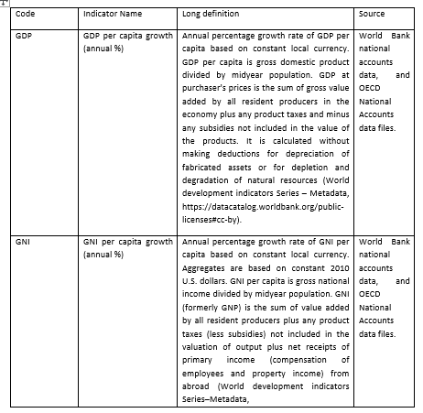

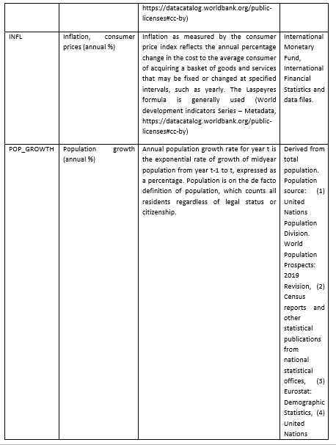

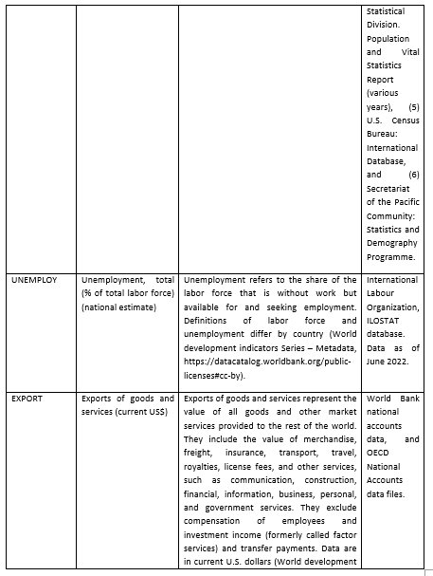

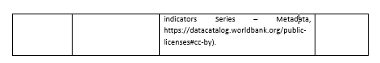

The R code below was used to check for missing values in the dataset after reading into R Studio. The dataset was then read into a Data frame. It can be seen that there are no missing values in the dataset.

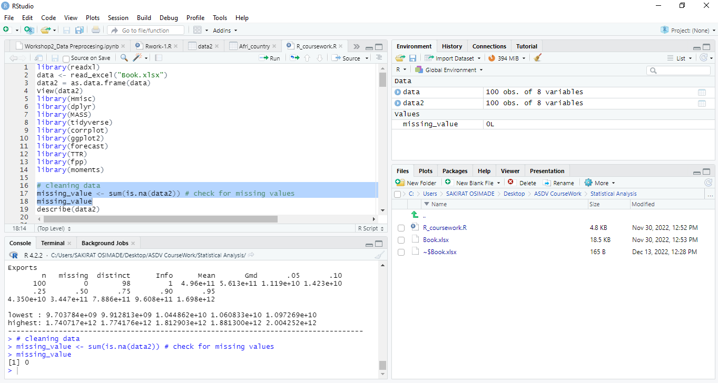

Figure : Checking for Missing values

# Analysis

* **Descriptive Analysis**

For the Descriptive Analysis, finding the Mean, Median, Standard Deviation, Skewness and Kurtosis of the Datasets, I used the **Describe** and **Summary, Skewness and Kurtosis** functions in R. For Mode, I defined a function for this.

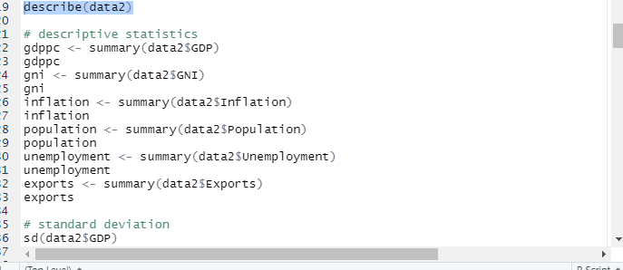

Figure : Using Describe and Summary Function in R

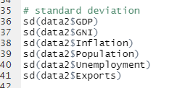

Figure : Standard Deviation

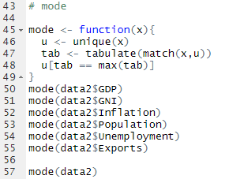

Figure : Mode

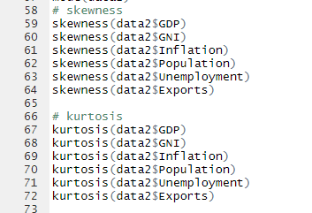

Figure : Skewness and Kurtosis

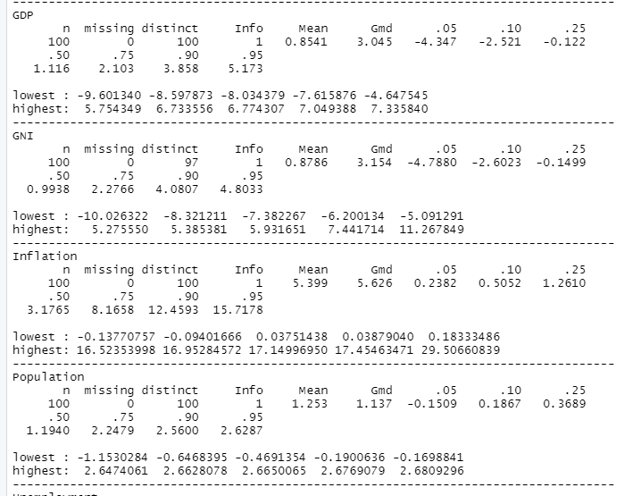

Figure : Result Using Summary Function for Descriptive Analysis

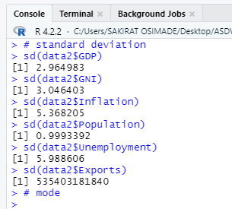

Figure : Standard Deviation of the Datasets

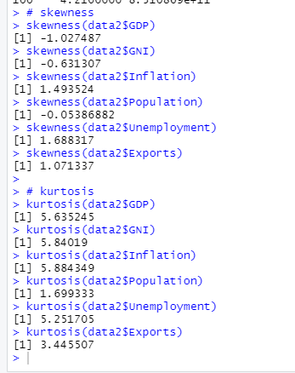

Figure : Skewness and Kurtosis of the Datasets

Table : Descriptive Analysis

|  |  |  |  |  |  |  |
| --- | --- | --- | --- | --- | --- | --- |
| **Country** | **Statistics** | | | | | |
| **Average** | **Middle value** | **Most appeared value** | **Standard deviation** | **The Skewness value** | **The Kurtosis value** |
| **GDP** | 0.8541 | 1.1164 | None | 2.964983 | -1.02748 | 5.635245 |
| **GNI** | 0.8786 | 0.9938 | 0.9938093 | 3.046403 | -0.63130 | 5.84019 |
| **INFL** | 5.399 | 3.1765 | None | 5.368205 | 1.493524 | 5.884349 |
| **POP_GROWTH** | 1.253 | 1.1940 | None | 0.9993392 | -0.05386 | 1.699333 |
| **UNEMPLOY** | 8.506 | 7.0600 | None | 5.988606 | 1.688317 | 5.251705 |
| **EXPORT** | 4.96e+11 | 3.447e+11 | 23206601901 14369518806 | 535403181840 | 1.071337 | 3.445507 |

The table above shows the descriptive statistics of the Economic indicators collected for all countries of interest. The table reveals different statistics measure which are mean, median, mode, standard deviation, skewness and kurtosis. The table shows that the average gross domestic product from the year 2012 to 2021 for all the countries by percent is approximately 85.41% which is term as high gross domestic product of the local currency for each country. The mean value of inflation per year and throughout the countries shows that there is an increase in Price of goods and services by 5.399 whereas the population growth at this time also increased by 1.253 per year and country, unemployment was also on an increased rate by 8.506 as year goes by especially in Africa and its rate of goods and services exported increased sporadically which could have led to high gross national income of each country.

* **Correlation Analysis**

The Table and plot reveal the correlation of the economic indicators and this analysis is essential before further analysis can be performed. It shows that gross domestic product which is the dependent variable has a positive association with the gross national income of about 83.27%, a positive association with inflation of about 11.15%, a positive association with population growth of about 12.36% but negative association with unemployment of about 19.55% and a negative association with export of goods and services of about 5.26%. this will be essential and more understood when we perform further analysis.

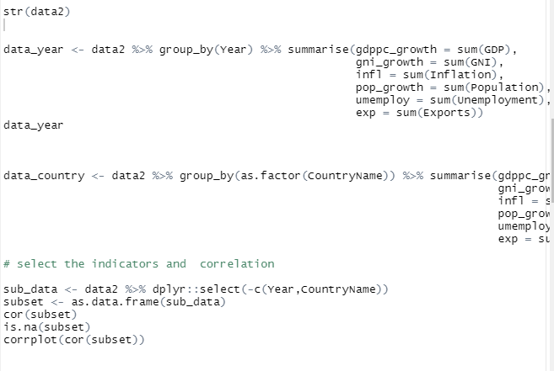

Figure : Correlation Analysis Code in R Studio

Table : Correlation Analysis

|  |  |  |  |  |  |  |
| --- | --- | --- | --- | --- | --- | --- |
|  | **ECONOMIC INDICATOR** | | | | | |
| **GDP** | **GNI** | **INFL** | **POP_GROWTH** | **UNEMPLOY** | **EXPORT** |
| **GDP** | 1.000 | 0.8327 | 0.1115 | 0.1236 | -0.1955 | -0.0526 |
| **GNI** | 0.8327 | 1.0000 | 0.1018 | 0.1984 | -0.2057 | -0.1007 |
| **INFL** | 0.1115 | 0.1018 | 1.0000 | 0.7756 | 0.0179 | -0.6311 |
| **POP_GROWTH** | 0.1235 | 0.1985 | 0.7756 | 1.0000 | -0.0208 | -0.7582 |
| **UNEMPLOY** | -0.1955 | -0.2057 | 0.0179 | -0.0208 | 1.0000 | -0.2865 |
| **EXPORT** | -0.0526 | -0.1007 | -0.6311 | -0.7582 | -0.2865 | 1.0000 |

Figure : Correlation Analysis Graph

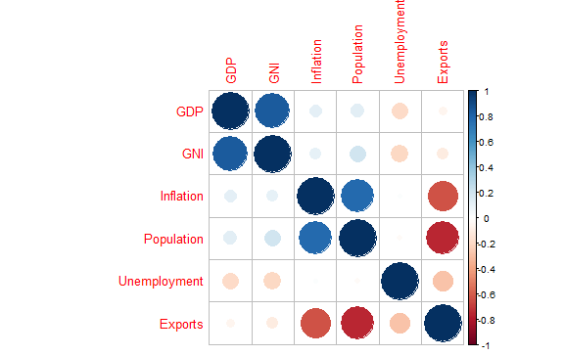

* **Regression Analysis**

A multiple linear regression was selected for this analysis which is meant to be used to deduce significant relationship between the Explanatory variables on the explained variable. This model is suitable because it can be used to get information on data with more than one independent variable but one dependent variable like ours. It was also selected because our data contain numeric quantitative variables.

Figure : Code for Regression Analysis in R Studio

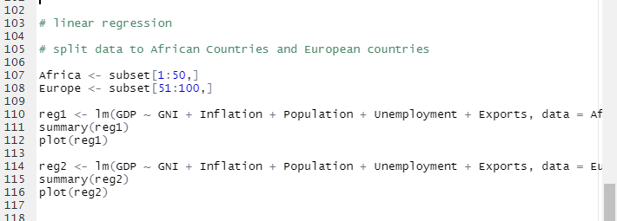

Figure : Regression Analysis for the Two Continents

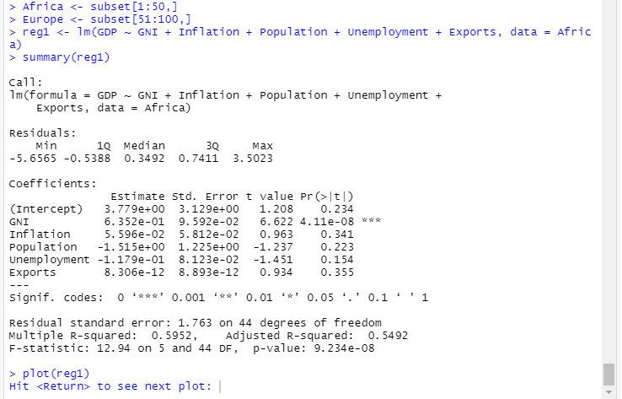

Table : Regression Output of Africa Economic Growth

|  |  |  |  |  |  |  |
| --- | --- | --- | --- | --- | --- | --- |
| **Dependent variable: GNP** | | | | | | |
| **coefficients** | | **Estimates** | | **Std. Error** | **t-value** | **P-value** |
| **GNI** | | 0.652 | | 0.0959 | 6.622 | 4.11e-08 |
| **Inflation** | | 0.0596 | | 0.0581 | 0.963 | 0.341 |
| **Population** | | -1.515 | | 1.225 | -1.237 | 0.223 |
| **Unemployment** | | 0.1179 | | 0.0812 | -1.461 | 0.154 |
| **Exports** | | 8.302e-12 | | 8.893e-12 | 0.934 | 0.355 |
| **R-square** | 0.5952 | | **P-values** | | 9.234e-08 | |
| **Std. error** | 1.763 | | **Adjusted R-square** | | 0.5492 | |
|  |  | | **F-statistics0** | | 12.94 | |

**Hypothesis:**

**H0:** Economic indicators has no significance effect on Gross domestic product

**H1:** Economic indicators has significance effect on Gross domestic product

**Rule:** Reject the null hypothesis (H0) if the p-value is less than 0.05

The Table shows the significant effect between the Explanatory variables on the explained variable. The table shows that there is a positive relationship between gross domestic product and gross national income which means that as gross national income increases by 1 percent, gross national product increases by 65.2%. This shows that the average percent of African countries per year increases by 65.2% if the gross national product increases, inflation has a positive relationship on gross national product which implies when goods and services are inflated by 1 percent, it increases the gross national product by 5.96%, population shows a negative effect on the gross national product which shows that as population increases, gross national product decreases by 1.515, the relationship between unemployment and gross national product is positive which shows that an increase in population reveals an increase gross national product by 11.79% and there is a positive effect of export of goods and services on gross national product which means an increase in export of goods and services leads to an increase in gross national product though the effect is insignificance but we can deduce that there is a positive effect whereas the R-square is used to measure the efficiency or accuracy of the model on the data. We can deduct from the table that the model shows 59.52% on the data which means the model fit the data by 59.52%. We reject the null hypothesis from the p-value (9.234e-08) since the p-value is less than 0.05 and we conclude that the factors of economy have significance effect on Gross domestic product.

Figure : Normal Q-Q for Africa Economic Growth

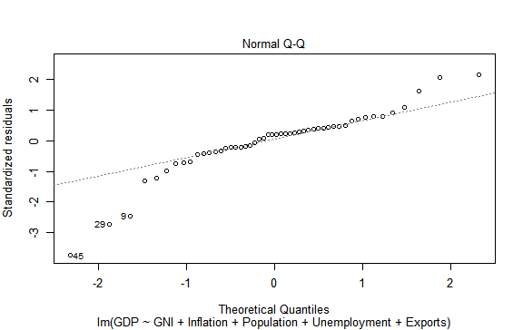

The plot above is the normality plot which proves that the data obey the normality assumption, so it is fit for further analysis.

Table :Regression output of Europe Economic Growth

|  |  |  |  |  |  |  |
| --- | --- | --- | --- | --- | --- | --- |
| **Dependent variable: GNP** | | | | | | |
| **coefficients** | | **Estimates** | | **Std. Error** | **t-value** | **P-value** |
| **GNI** | | 0.9371 | | 0.0673 | 14.044 | <2e-16 |
| **Inflation** | | 0.5784 | | 0.2496 | 2.317 | 0.0252 |
| **Population** | | -0.5314 | | 0.5214 | -1.019 | 0.3137 |
| **Unemployment** | | -0.0512 | | 0.0947 | -0.541 | 0.5914 |
| **Exports** | | -4.368e-13 | | 5.989e-12 | -0.729 | 0.4696 |
| **R-square** | 0.8346 | | **P-values** | | 4.158e-16 | |
| **Std. error** | 1.402 | | **Adjusted R-square** | | 0.8159 | |
|  |  | | **F-statistics0** | | 44.42 | |

**Hypothesis:**

**H0:** Factors of Economy has no significance effect on Gross domestic product

**H1:** Factors of Economy has significance effect on Gross domestic product

**Rule:** Reject the null hypothesis (H0) if the p-value is less than 0.05

The Table shows the relationship between the Explanatory variables on the explained variable. There is a positive relationship between gross domestic product and gross national income which means that as gross national income increases by 1 percent, gross national product increases by 93.71%. This shows that the average percent of European countries per year increases by 93.71% if the gross national product increases, inflation has a positive relationship on gross national product which implies when goods and services are inflated by 1 percent, it increases the gross national product by 57.84%, population shows a negative effect on the gross national product which shows that as population increases, gross national product decreases by 53.14%, the relationship between unemployment and gross national product is negative which shows that an increase in unemployment reveals a decrease gross national product by 5.12% and there is a negative effect of export of goods and services on gross national product which means an increase in export of goods and services leads to a decrease in gross national product though the effect is insignificance whereas the R-square is used to measure the efficiency or accuracy of the model on the data. We can deduct from the table that the model shows 83.46% on the data which means the model fit the data by 59.52%. We reject the null hypothesis from the p-value (4.158e-16) since the p-value is less than 0.05 and we conclude that the Economic indicators has significance effect on Gross domestic product.

Figure : Normal Q-Q for Europe Economic Growth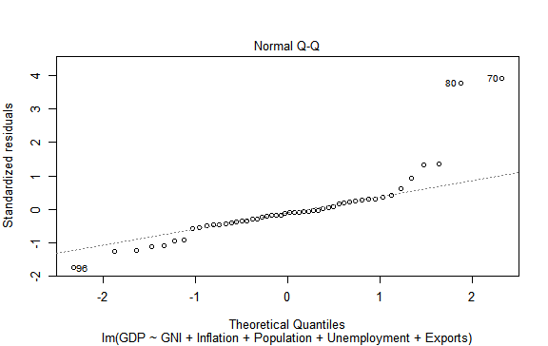

The plot above is the normality plot which proves that the data obey the normality assumption, so it is fit for further analysis.

* **Time series analysis**

**Time series analysis of Africa Economic growth**

Figure : Time Series Plot of African Countries

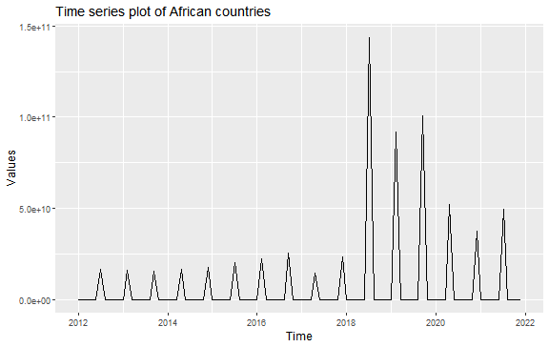

There is a positive trend over time and there seems to be a seasonality pattern which we will investigate in further plot, but we will notice that the economy increases in 2019 then decreases which shows an unstable trend over the years.

Figure : Time Series Plot of First Difference African Countries

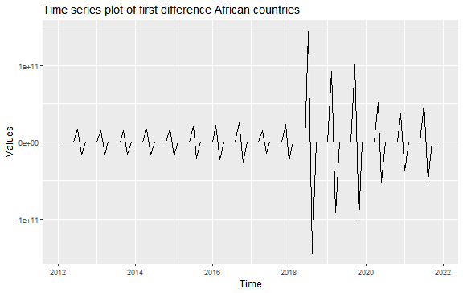

First difference was conducted on the data in order to remove trends and check seasonality, we could deduce from this plot that the pattern over the years is not concurrent which simply means that the trends has been removed and the data is stationary over time.

Figure : Time Series Plot of seasonality for African Countries

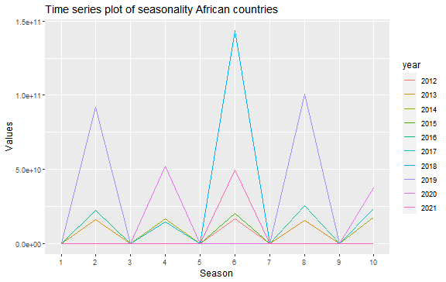

The graph shows a fluctuation in the economy per year, it is obvious that the economy is stable at 3 years interval which shows that season is a major factor that affects the economy.

**ARIMA Model for Economic Growth in African Countries**

Table : ARIMA Model Africa

|  |  |  |  |  |
| --- | --- | --- | --- | --- |
| **Dependent variable: GNP** | | | | |
| **coefficients** | **Estimates** | **Std. Error** | **p-value** | 0.001493 |
| **Ar1** | -0.8595 | 0.0672 | variance | 4.305e+20 |
| **Ar2** | -0.9061 | 0.0632 | AIC | 4493.93 |
| **Ar3** | -0.7724 | 0.0793 | BIC | 4508.86 |
| **Ar4** | -0.8766 | 0.0599 | AIC c | 4494.96 |
| **Ar5** | -0.7400 | 0.0648 | Log likelihood | -2240.87 |

Figure : Residuals from ARIMA for Africa

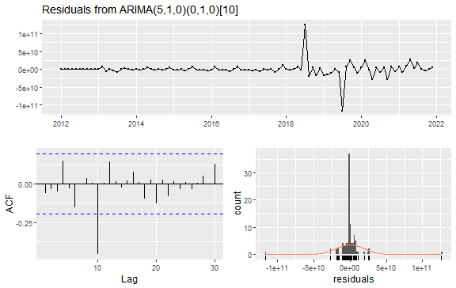

**Time series analysis of Europe Economic growth**

Figure : Time Series Plot for European Countries

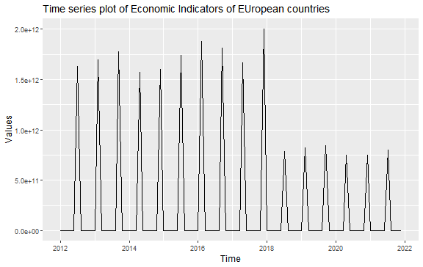

There is positive trend over time and there seems to be a seasonality pattern which we will investigate in further plot, but we will notice that the economy increases steadily from 2012 to 2018 but decreases rapidly which could be due to the pandemic.

Figure : Time Series plot of first difference for European Countries

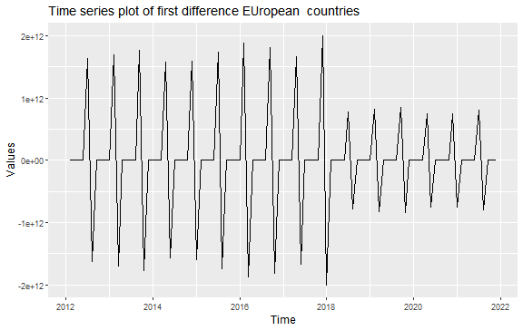

First difference was conducted on the data in order to remove trends and check seasonality, we could deduce from this plot that the pattern over the years is not concurrent which simply means that the trends has been removed and the data is stationary over time.

Figure : Time Series Plot of seasonality for European Countries

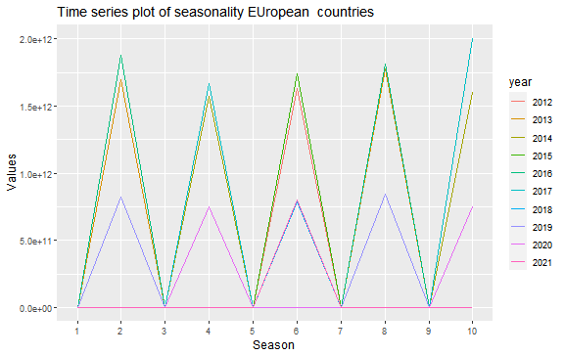

The graph shows a steady pattern over rime which simply means the economy doesn’t depend on season or does season influences the economy.

**Arima Model for Economic Growth in European Countries**

Table : ARIMA Model Europe

|  |  |  |  |  |
| --- | --- | --- | --- | --- |
| **Dependent variable: GNP** | | | | |
| **coefficients** | **Estimates** | **Std. Error** | **p-value** | 3.65e-15 |
| **Ar1** | -0.0196 | 0.0321 | variance | 7.22e+22 |
| **Ar2** | -0.9421 | 0.0328 | AIC | 4955.43 |
| **Ar3** | -0.0183 | 0.0321 | BIC | 4970.36 |
| **Ar4** | -0.9437 | 0.0266 | AIC c | 4495.45 |
| **Ar5** | -0.7716 | 0.0809 | Log likelihood | -2471.71 |

Figure : Residuals from ARIMA for Europe

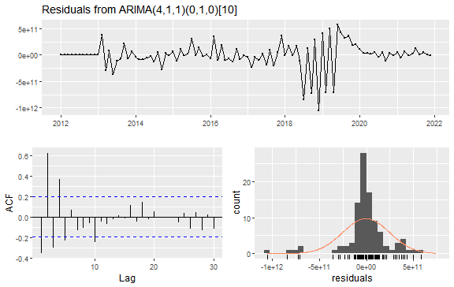

**Forecast of Economic Growth in Africa**

Figure : 10 Years Forecast for Africa Economic Growth

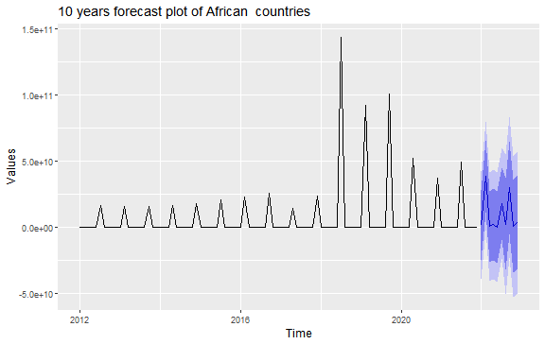

The graph is a forecast for the next 10 years which reveals that Africa countries’ economy has a tendency of decrease over the coming years.

**Forecast of Economic Growth in Europe**

Figure : 10 Years Forecast for Europe Economic Growth

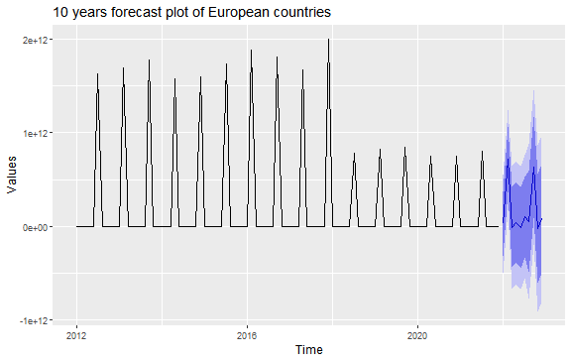

The graph is a forecast for the next 10 years which reveals that European countries’ economy will have steady economic growth for the next 10 years.

The forecast shows that Europe tends to experience an increase in economic growth than Africa in the next ten years which simply means Europe has a better economic growth than Africa either being affected by pandemic or not.

* **Comparative Analysis**

Hypothesis 1:

H0: there is no significance difference between the Africa Economic growth and European Economic growth

H1: there is significance difference between the Africa Economic growth and European Economic growth

|  |  |  |
| --- | --- | --- |
|  | Africa Economic growth | Europe Economic growth |
| **R-square** | 0.5962 | 0.8346 |
| P-value | 9.234e-08 | 4.158e-16 |

The p-value of the two Continent shows a significance difference since it is less than 0.05 but this will be supported with the R-square which predicts that the continent with the highest R-value shows more significance than the other there is significance difference between the European Economic growth and the Africa Economic growth. It is obvious in the output that European Economic growth has 83.46% R-value compared to the Africa Economic growth which is 59.62%. We can conclude by rejecting the null hypothesis and say, there is significance difference between the Africa Economic growths and European Economic growth.

Hypothesis 2:

H0: there is no significance difference between the forecasted Africa Economic growth and European Economic growth

H1: there is significance difference between the forecasted Africa Economic growth and European Economic growth

|  |  |  |
| --- | --- | --- |
|  | Africa Economic growth | Europe Economic growth |
| AIC | 4493.93 | 4955.43 |
| BIC | 4508.86 | 4970.36 |

# DISCUSSION

In addition to our regression analysis, it is necessary not to conclude this research on prior information alone which is the limitation of the regression analysis, it is important to predict the economic growth of both continents in year to come not only for the purpose of this research study but to see if there is a tendency for either of the continent will do much better in years to come. For this purpose, a time analysis is suitable to predict years to come and to see which have the tendency to do much better.

Two statistical measures were taken to consideration in order to know which continent has a better forecast and to look out for in relation to economic growth. The first measure is called the Akaike Information Criterion (AIC) which is a goodness of fits to compare different model and its best fit. The second one is called the Bayesian Information Criterion which is used like the AIC. They are both goodness of fit measurement. The AIC and BIC assumption is that the lower its value, the better the model.

So, comparing the two measures, it is obvious that Africa Economic growth has a lower AIC and BIC value, which implies it has a better forecast than Europe Economic growth, so we reject the null hypothesis

We conclude that Africa tends to experience an increase in economic growth than Europe in the next ten years which simply means Africa could have a better economic growth than Europe in future years.

# Conclusion

The findings of the descriptive analysis of the Economic Indicators of the selected African and European Countries indicates positive population growth rate and gross domestic product growth rate across the countries

From the Correlation Analysis, the findings indicated that Dependent variable was set to be the GDP and this had positive association with the Gross National Income and Population Growth. It also had a negative association with Export of Goods and Services and Unemployment.

The Regression Analysis tested a hypothesis around the significant effect of other Economic Indicators on Gross Domestic Product. The findings indicate there is a positive relationship between Gross Domestic Product and Gross National Income. In addition, there is a Positive effect of export of Goods and services on Gross National Income.

The Regression Model fits the data by 59.52% and we reject the null hypothesis and conclude that the Economic Indicators (GNI, Import, Export, Inflation, Population and Unemployment) all have significant effect on the Gross Domestic Product of the Countries investigated for both the African Continent and the European Continent.

# Part Three: References and Appendices

Acemoglu, D., Johnson, S. and Robinson, J. (2005), ‘The Rise of Europe: Atlantic Trade, Institutional Change and Economic Growth’, American Economic Review, 95, 546-79.

Acemoglu, D. and Robinson, J. A. (2010), “Why is Africa Poor?”, Economic History of Developing Regions, 25:1, 21-50. African Economic Outlook (2010), African Economic Outlook, 2010, <http://www.africaneconomicoutlook.org/en/>.

Ajam, T. and Aron, J. (2007), ‘Fiscal renaissance in a democratic South Africa’, Journal of African Economies 16: 745-81.

Allen, R. C. (2000), ‘Economic structure and agricultural productivity in Europe, 1300- 1800’, European Review of Economic History 3: 1-25.

Álvarez-Nogal, C. and Prados de la Escosura, L. (2013), ‘The Rise and Fall of Spain, 1270-1850’, Economic History Review, 66, 1-37.

Baskaran, T. and Bigsten, A. (2013), ‘Fiscal capacity and the quality of government in sub-Saharan Africa’, World Development 45: 92-107.

Berg, A., Ostry, J. D. and Zettelmeyer, J. (2008), ‘What Makes Growth Sustained?’, IMF Working Paper 08/59. Block, S. A. (2002), ‘Political business cycles, democratization, and economic reform: the case of Africa’, Journal of Development Economics 67: 205-228.

Boshoff, W. and Fourie, J. (2010), ‘The significance of the Cape trade route to economic activity in the Cape Colony: A medium-term business cycle analysis’, European Review of Economic History 14: 469-503.

Bridbury, A. R. (1962), Economic Growth: England in the Later Middle Ages, London: George Allen and Unwin.

Broadberry, S., Campbell, B., Klein, A., Overton, M. and van Leeuwen, B. (2011), ‘British Economic Growth, 1270-1870: An Output-Based Approach’, London School of Economics, <http://www2.lse.ac.uk/economichistory/whosho/profiles/sbroadberry.aspx>.

Broadberry, S., Campbell, B., Klein, A., Overton, M. and van Leeuwen, B. (2014), British Economic Growth, 1270-1870, Cambridge: Cambridge University Press.

Broadberry, S, Campbell, B. and van Leeuwen, B. (2013), “When did Britain Industrialize? The Sectoral Distribution of the Labor Force and Labor Productivity in Britain, 1381-1851”, Explorations in Economic History, 50, 16-27.

Chenery, H. and Syrquin, M. (1975), Patterns of development, 1950-1970, Oxford: Oxford University Press.

Crafts, N. F. R. (1984), ‘Patterns of Development in Nineteenth Century Europe’, Oxford Economic Papers 36, 438-58.

Crafts, N.F.R. (1985), British Economic Growth during the Industrial Revolution, Oxford: Clarendon Press. Deane, P. and Cole, W.A. (1967), British Economic Growth, 1688-1959: Trends and Structure, 2nd edition, Cambridge: Cambridge University Press.

Dincecco, M. (2011), Political Transformations and Public Finances: Europe, 1650- 1913, Cambridge: Cambridge University Press.

Feinstein, C. H. (2005), An economic history of South Africa: conquest, discrimination and development, Cambridge: Cambridge University Press.

Ferguson, J. (1999), Expectations of Modernity: Myths and Meanings of Urban Life on the Zambian Copperbelt, Berkeley: University of California Press.

Findlay, R. and O’Rourke, K. H. (2007), Power and Plenty: Trade, War, and the World Economy in the Second Millennium, Princeton, NJ: Princeton University Press. 44 Flynn, D. O. (1982), ‘Fiscal crisis and the decline of Spain (Castile)’, Journal of Economic History 42: 139-47.

Edith Forsyth (2022), Economic Indicators, [https://www.student.unsw.edu.au/how-do-i-cite-](https://www.student.unsw.edu.au/how-do-i-cite-electronic-sources) [electronic-sources](https://www.student.unsw.edu.au/how-do-i-cite-electronic-sources)

Anon., Functions Of An Effective Dashboard, [https://www.bartleby.com/essay/Functions-Of-An-](https://www.bartleby.com/essay/Functions-Of-An-Effective-Dashboard-PKUXUHKVUXYW#%3A~%3Atext%3DMost%20commonly%2C%20a%20dashboard%20is%2Cneeded%20to%20achieve%20business%20objectives) Effective-Dashboard-[PKUXUHKVUXYW#:~:text=Most%20commonly%2C%20a%20dashboard%20is,needed%20to](https://www.bartleby.com/essay/Functions-Of-An-Effective-Dashboard-PKUXUHKVUXYW#%3A~%3Atext%3DMost%20commonly%2C%20a%20dashboard%20is%2Cneeded%20to%20achieve%20business%20objectives)

[%20achieve%20business%20objectives.](https://www.bartleby.com/essay/Functions-Of-An-Effective-Dashboard-PKUXUHKVUXYW#%3A~%3Atext%3DMost%20commonly%2C%20a%20dashboard%20is%2Cneeded%20to%20achieve%20business%20objectives)

Leslie Kramer (2022), How Importing and Exporting Impacts the Economy

[https://www.investopedia.com/articles/investing/100813/interesting-facts-](https://www.investopedia.com/articles/investing/100813/interesting-facts-about-imports-and-exports.asp#%3A~%3Atext%3DA%20country%27s%20importing%20and%20exporting%2Con%20a%20country%27s%20exchange%20rate) [about-imports-and-](https://www.investopedia.com/articles/investing/100813/interesting-facts-about-imports-and-exports.asp#%3A~%3Atext%3DA%20country%27s%20importing%20and%20exporting%2Con%20a%20country%27s%20exchange%20rate) [exports.asp#:~:text=A%20country's%20importing%20and%20exporting,on%](https://www.investopedia.com/articles/investing/100813/interesting-facts-about-imports-and-exports.asp#%3A~%3Atext%3DA%20country%27s%20importing%20and%20exporting%2Con%20a%20country%27s%20exchange%20rate) [20a%20country's%20exchange%20rate](https://www.investopedia.com/articles/investing/100813/interesting-facts-about-imports-and-exports.asp#%3A~%3Atext%3DA%20country%27s%20importing%20and%20exporting%2Con%20a%20country%27s%20exchange%20rate).

J.B Maverick, (2022), Measuring Economic Conditions: GNI or GDP [https://www.activebs.com/en/power-bi/why-power-bi#:~:text=Benefits%20of%20Power%20BI&text=Power%20BI%20can%20collect%20your,their](https://www.activebs.com/en/power-bi/why-power-bi#%3A~%3Atext%3DBenefits%20of%20Power%20BI%26text%3DPower%20BI%20can%20collect%20your%2Ctheir%20data%20quickly%20and%20easily)

[%20data%20quickly%20and%20easily.](https://www.activebs.com/en/power-bi/why-power-bi#%3A~%3Atext%3DBenefits%20of%20Power%20BI%26text%3DPower%20BI%20can%20collect%20your%2Ctheir%20data%20quickly%20and%20easily)

Bondarenko, Peter. "Unemployment rate". Encyclopedia Britannica, [https://www.britannica.com/topic/unemployment-rate. Accessed 1 December](https://www.britannica.com/topic/unemployment-rate.%20Accessed%201%20December%202022) [2022](https://www.britannica.com/topic/unemployment-rate.%20Accessed%201%20December%202022).